|  |  |
| --- | --- |
| Date | 28 October 2022 |
| Team ID | PNT2022TMID00315 |
| Project Name | Project - IoT Based Smart Crop Protection System for Agriculture |
| Maximum Marks | 4 Marks |

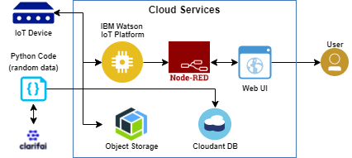

**Table-1 : Components & Technologies:**

|  |  |  |  |
| --- | --- | --- | --- |
| **S.No** | **Component** | **Description** | **Technology** |
|  | User Interface | How user interacts with application e.g.  Web UI, Mobile App, Chat bot etc. | HTML, CSS, JavaScript. |
|  | Application Logic-1 | Logic for a process in the application | Python |
|  | Application Logic-2 | Logic for a process in the application | IBM Watson/ clarify |
|  | Application Logic-3 | Logic for a process in the application | IBM Watson/node red |
|  | Database | Data Type, Configurations etc. | MySQL, NoSQL. |
|  | Cloud Database | Database Service on Cloud | IBM cloud, IBM DB etc |
|  | Temperature sensor | Monitor the temperature | TMP36 |
|  | Humidity sensor | Monitor the humidity | DHT11 |
|  | Soil moisture sensor | Measure the amount of water in the soil | Soil moisture sensor |
|  | File Storage | File storage requirement | IBM block storage or local file system |

**Table-2: Application Characteristics:**

| **S.No** | **Characteristics** | **Description** | **Technology** |
| --- | --- | --- | --- |
|  | Open-Source Frameworks | Open-source framework is used | python |
|  | Security Implementations | Sensitive and private data must be protected from their protection until the decision-making and storage stages. | Encryption process |
|  | Scalable Architecture | Scalability is a major concern for IOT platform it has been shown that different architectural choices of IOT platform affect system capability and that automatic real time decision making is feasible in an environment composed of dozens of thousand. | Web UI application server-python, clarify database server-IBM cloud services Technology. |
|  | Availability | Automatic adjustment of farming equipment made possible by linking information like crops/weather and temperature,humidity etc. | IBM cloud services |
|  | Performance | The ideas of implementing integrated sensors with sensing soil and environmental or ambient parameters in framing will be more efficient for overall monitoring . | IBM cloud services |